Theme:
Warm light taupe/sandy tones, possibly light blue and olive accents and wording
examples
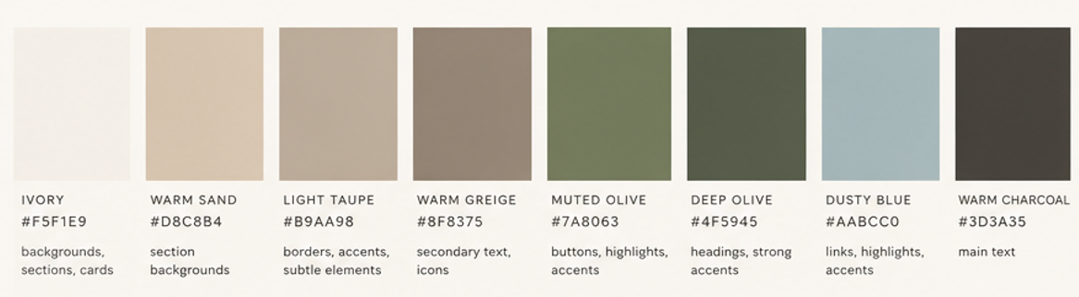

Home Page
Top Tabs
Left
Home Stock Cabinetry Custom Cabinetry Countertops Flooring
Centered TWO G’S IN A POD
Design & Interiors
Right
Spaces We’ve Created About Us Contact Us Search

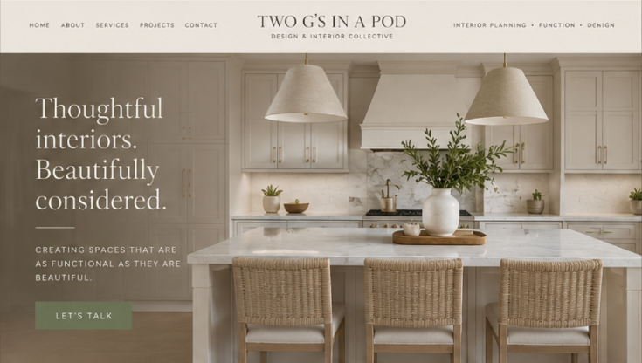
Main Photo Heading
Thoughtful interiors. Beautifully considered
_____
Creating spaces that are as functional as they are beautiful.
Button Let’s Talk (directed to contact us page with form)
Photo behind
Remove

Our Philosophy
Merging exceptional design with tailormade cabinetry, we curate spaces from concept to completion, distinguished by precision, craftsmanship, and an unwavering attention to every detail.

I do what two Scroll Bars (like on www.gginapod.com)
Stock Cabinetry (click name to redirect to main stock cabinetry page)
Door tiles scrolling
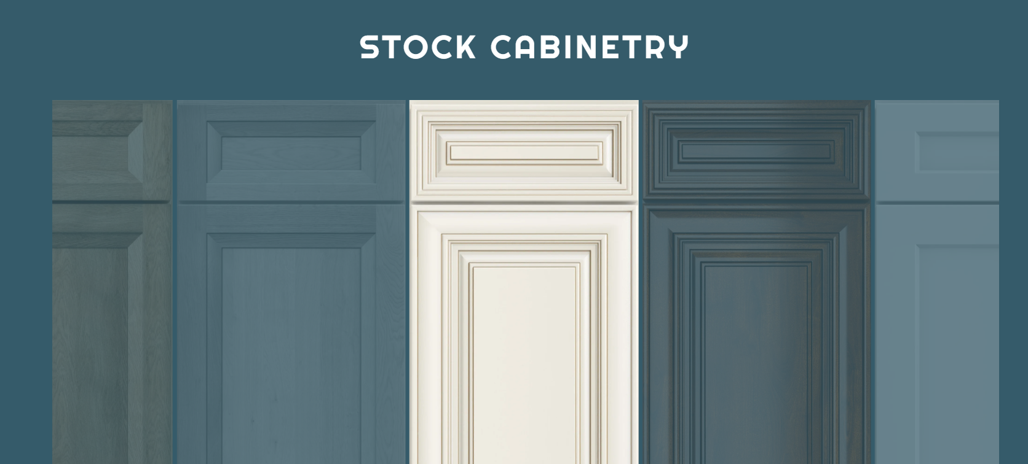Custom Cabinetry (click name to redirect to custom cabinetry page)
Door tiles scrolling (do not need to be clickable)
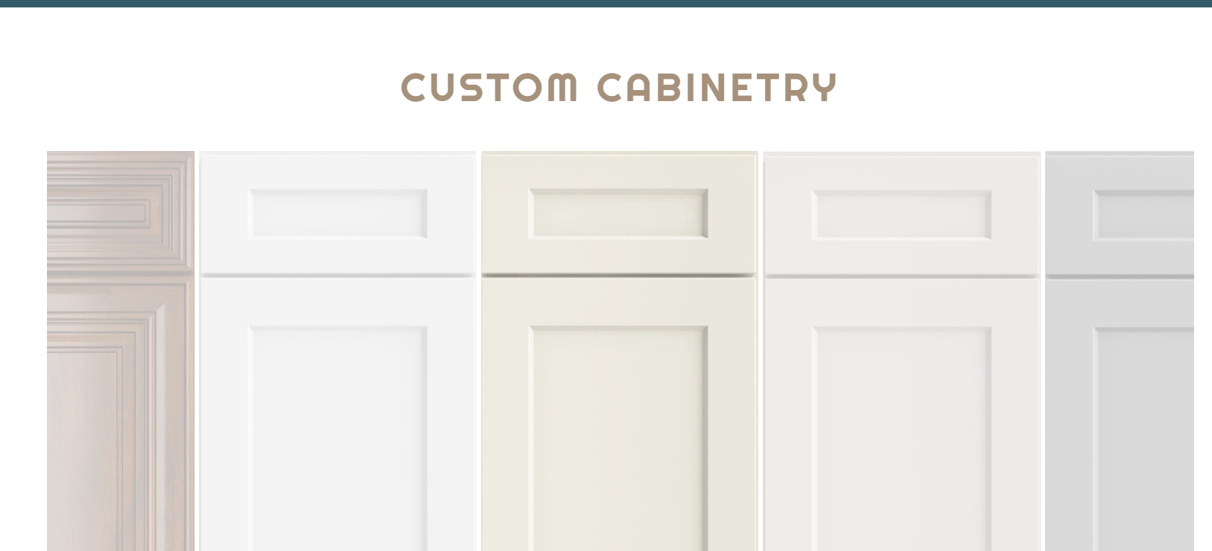

Remove
Finishes
How we work
Portfolio

Keep
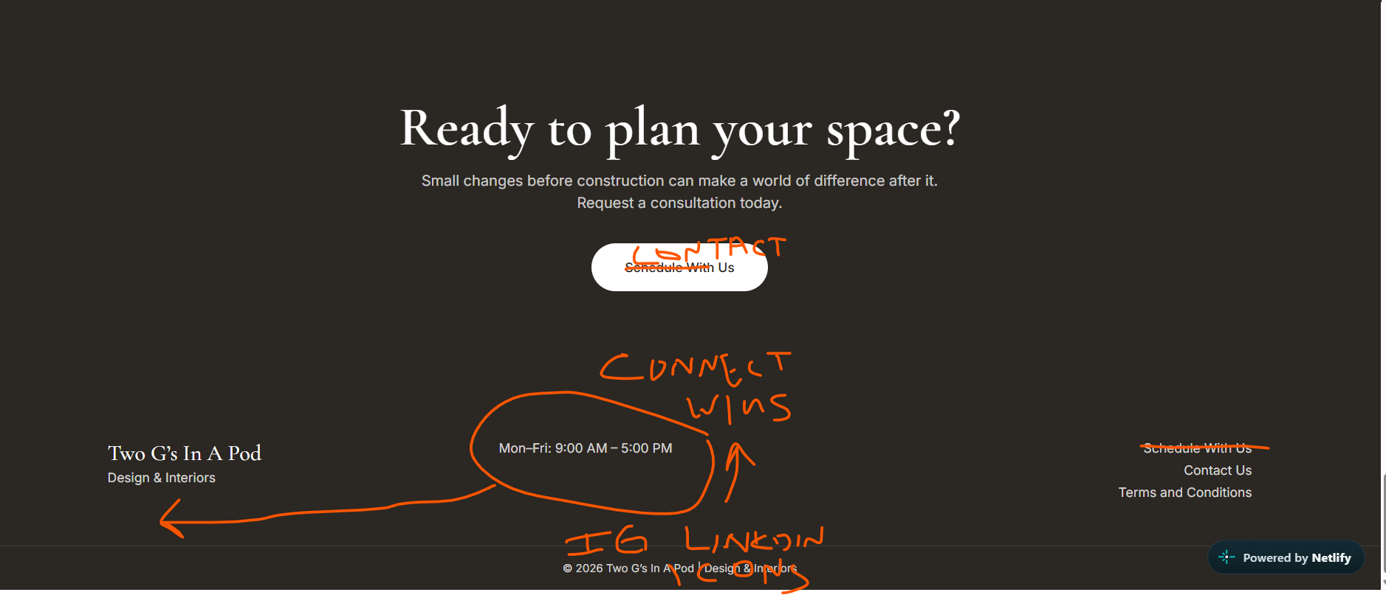
Tabs
Left Center Left
Two G’s In A Pod Connect with Us Contact Us
Design & Interiors IG & LinkedIn Icons FAQ’s
Monday – Friday 9:00am-5:00pm
702-418-2018

Individual Pages
Stock Cabinetry
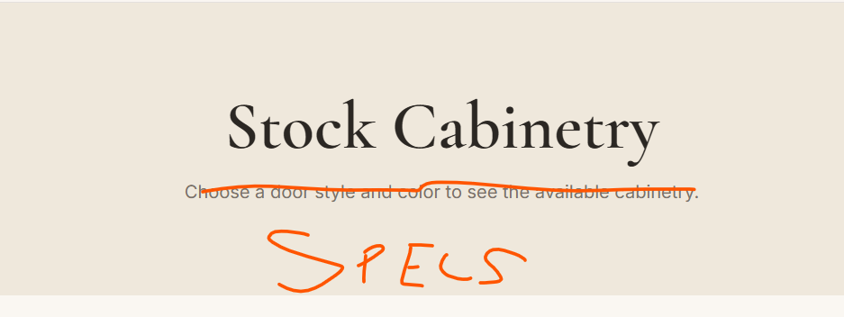
4 tiles across
Remove: Door style & Color just leave Name
Add Specs:
Box Material | 1/2" Birch Plywood
Box Interior | Natural Birch Interior
Box Face Frame | 3/4" x 1-1/2" Solid Birch
Door Material | Solid Wood Frame, MDF Panel
Door Style | Full Overlay
Door Hinges | Soft Close, Concealed, 6-Way Adjustable
Drawer Glides | Soft Close Undermount Full Extension
Drawer Material | 5/8" wood, Dovetail
Shelves | 3/4" Plywood, Adjustable, full in wall, ½ depth in base

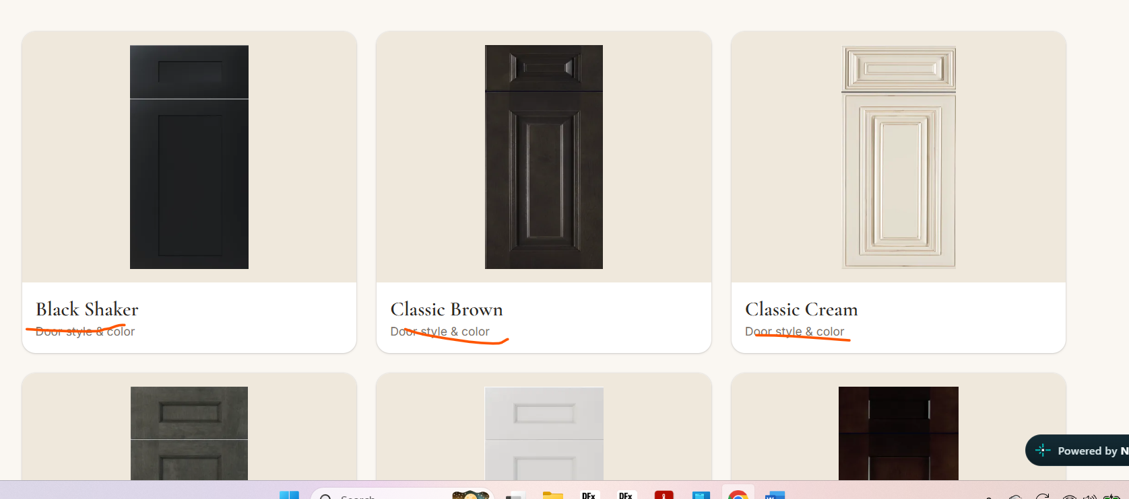

I like the way the tiles are on the Custom Cabinetry page, make Stock the same with no large boarders just full door style tiles, not cropped, no rounded edges on door tiles they have to be square

Add filter tabs to select
Flat Panel - Shaker – Double Shaker - Slim Shaker - Raised Panel
Flat panel (I will add at later date)
Shaker
White, Black, Espresso, Grey, Moon Grey, Natural, Navy, Pine Green, Rustic Wood, Sage
Double Shaker
Double Smoked, Double White
Slim
Oak, Pine, White
Raised panel
Classic Cream, Classic Brown, Traditional White

When you click on tile

Display
FULL tile, not cropped, no rounded edges
Tile photo
Name
Remove door style and color
Remove
Collection
# of items available
Schedule with us
boarder around tile, full tile only
No all tab

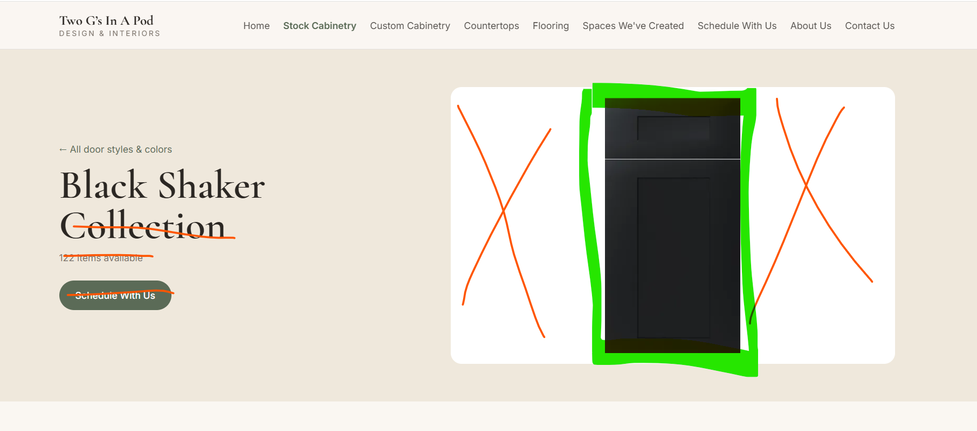

---------------------
Custom Cabinetry

Reword: Choose every detail, from your door profile to your perfect stain or paint color

Door tiles are okay, full tiles, don’t love the white boarder, no rounded edges for door profiles, have to stay square
Paint and stain can have rounded edges if it is better but I would rather have crisp corners
----------------------------------------------------------------
Mobile Version
HAMBURGER
Home
Stock Cabinetry
Custom Cabinetry
Countertops
Flooring
Spaces We've Created
Measurement Guide
Shipment & Delivery Information
About Us
Contact Us

